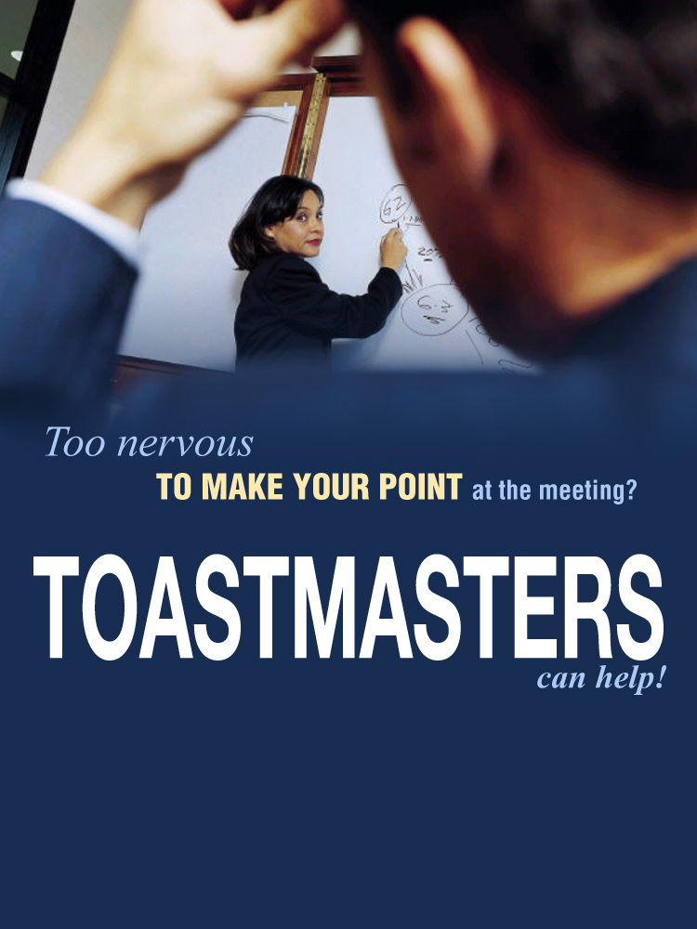

ABC Toastmasters Club

Thursdays: 4:00 PM to 6:30 PM

124 your Street, Sydney

Call 0416 000 000 or visit [www.clubname.com.au](http://www.clubname.com.au) for more information