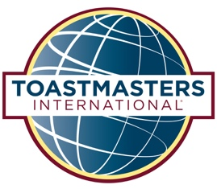
What can
Toastmasters
do for you?
Whether you’re a professional, student, stay-at-home parent, or retiree, Toastmasters is the best way to build great communication skills. You’ll learn how to successfully organize and present your ideas and yourself. Toastmasters will give you the skills and confidence you need to effectively express yourself in any situation.

- You’ll be a better listener

- You’ll comfortably give and receive constructive evaluations

You’ll effectively develop and present ideas

Toastmasters training can be a wise career move:

- You’ll give better sales presentations

- You’ll easily lead teams and conduct meetings

- You’ll hone management skills

You already have some or all of these skills.
Toastmasters will help you to enhance them.

VISITORS ALWAYS WELCOME!  Call 0416 000 000  for more information! |  | ABC Toastmasters Club  1st & 3rd Thursdays • 6:30 am - 7:45 am  Apple Valley Community Center  3 Bennington Drive, Balgowlah

